FILL OUT SHEET CONTRIBUTORS

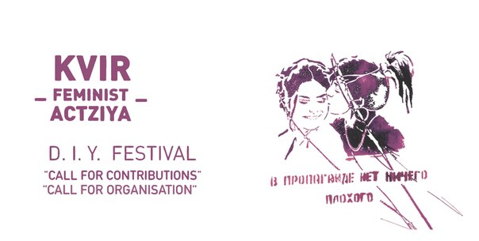
KVIR_FEMINIST_ACTZIYA_2014 24-27 July
D.I.Y. festival in Vienna

Please write as soon as possible but latest until 16th May 2014

We are a self organized political collective, just a bunch of activists and not some fancy established institution, therefore we need all participants to contribute to the organization of the festival as far as they have the resources and the time. Our Festival is a D.I.Y/D.I.T Festival, which stands for "do it yourself" and "do it together" and is about collectively shared responsibilities. There is more about this on our homepage. This also applies to the preparation: If you know people who have been to the festival last year, please get together and share information about visa and travel possibilities etc.

1. YOUR CONTRIBUTION
(This information is for the organization team but also for the program textbook)

- Your name / the name of your collective (As it should appear in the program textbook and on the webpage)

- Title of your contribution (As it should appear in the program textbook and on the webpage)

- Format of your contribution e.g. lecture, performance, workshop, exhibition, paintings etc.:

- Concept of your contribution (So we can get an idea of what you want to do)

- Short description of content (As it should appear in the program textbook and on the webpage)

- Any pictures, video material, links existing? (As it should appear on the festival webpage)

- Any other material/kvir_feminist propaganda we could publish in the program textbook? (Depends on how much space is left, though..)

- Should the country/city you are from be indicated in the program textbook? If so, please fill in:

- How much time do you need? (Approx)

- What kind of space do you need? (For how many people, accessibility...):

- Do you need any tools/materials? (e.g. notebook, projector, paint etc..)

Days of your participation in the festival:
In case you can’t participate all 4 days, let us know which dates are NOT possible, so we consider this for the scheduling:

o the 24th: I'm NOT there before ______ / from_____ to ______.

o the 25th I'm NOT there before ______ / from_____ to ______.

o the 26th I'm NOT there before ______ / from_____ to ______.

o the 27th I'm NOT there after ______ / from_____ to ______.

Invitation politix: Do you want to define invitation politix for your contribution?

o open to all (e.g. open to all genders etc.)

o open to all but (e.g. people from "the west" should rather listen than dominate the discussion,...should be aware of xxx...) my invitation politix are:

o not open to all, (e.g. only female, lesbian, inter and trans* people, only people who identify as trans, everybody except cis-men, no Westerners, no white people etc.) my invitation politix are:

Language and translation for your contribution

o translation not needed

o my possible languag/es is/are: , for other languages I need translation.

Translation for the whole festival

o translation not needed

o translation needed, my possible languag/es is/are:

o I can offer translation for others, possible language/es is/are:

Please position yourself on the concepts "queer" and "feminism" and d.i.y. /d.i.t (do-it-yourself/do-it-together)? What do these concepts mean to you? Why do you want to participate in our festival?

(A couple of sentences are enough. And this is not a "test" or something in terms how queer or feminist you are and we don't want you to write a fancy neoliberal motivation letter. However, we decided to include this question to get to know you a bit more. Also, the more we know about you/your collective and your personal agenda/position, the easier it is for us to compose and schedule the program.)

2. ACCOMMODATION

Do you have a place to sleep during the festival?

o If yes: skip the following and go to part 3.

o If no: please indicate the following. We will organize places to sleep in private flats of people who are willing to host you. We do not provide hotel reservation or such. If you want we can organize sleeping possibilities during the festival and/or for some days early or a couple days more.

I need a place to sleep from to (dates)
Number of nights:

Number of people:

Should the space be wheelchair accessible?
o yes
o no

Is it important for you to sleep in a place where no cis-men have access to?
o no, I don't care
o yes, I need a female, lesbian, trans*, intersex only-place

Do you have any further needs in terms of accommodation? (e.g. allergies according to pets, or single room because of whatever condition - but please be aware that we can certainly not provide everyone with single rooms):

3. Vegan and vegetarian FOOD will be provided and prepared together by participants and whoever is willing to volunteer during the festival. Do you have any allergies/intolerances or other specific nutritional needs?

4. VISA

IMPORTANT: If you need a visa, please in addition put “Visa” in the reference line of the mail!

o visa not needed

o visa needed, country:

o do you need money for visa / how much:

IMPORTANT: If you need a visa, please put “Visa” in the reference line of the mail! Seriously!

Please note: We can help you with getting the visa for Austria by providing you an invitation. Unfortunately we don’t have enough resources to organize all the information for you. Please try to find out the conditions the Austrian Embassy of your country has in terms of getting an Austrian Visa. As soon as you provide us with the information on what you need from us, we will do our best to assist you in getting the Visa in time.

5. TRAVEL COSTS

o support not needed

o amount of money needed:
o how much is the minimum of funding you would need from us in order to participate? (If you can cover part of your travelling costs yourself, that can help us to finance the travel expenses for as many people as possible.)

Please note: The finances for the festival are limited and the biggest part of it is spent on the travel costs. So please if you have any other possibility like getting a travel grant from a NGO, your work, a foundation etc, please use it in order to make it possible for other people to come to the festival, who don't have such opportunities.
Please do your best to choose the cheapest way of travel and book your tickets as soon as possible.

6. COMMUNICATION
Please fill in your contact data (please put the an Email that you check regularly, or something else if you really don’t have one)

7. Other stuff we forgot so far?

KVIR to all the people and aliens!
Hope to see you soon in Vienna.

Your kvir_feminist_collective

